Risk Management Plan

Name of the project: COVID-19 Clinic

Group: 27

List of group members

Soohwan Kim

Jacob Vanniejenhuis

Shayan Arif Shah

William Bates

1. Complete the risk breakdown structure

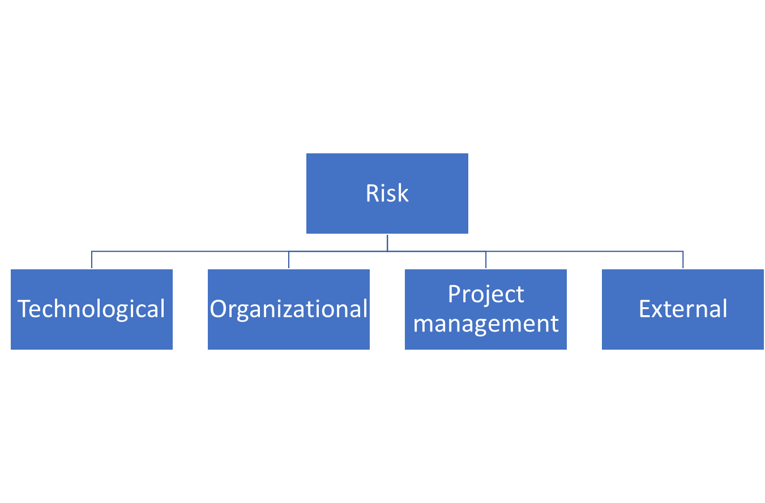

Technological:

* Record Keeping
* System Failures
* Power outage
* Lack of air conditioning/heat

Organizational:

* Funding
* Under staffed
* Security
* Lack of advertising
* Lack of seating
* Long wait times
* Not enough venue space

Project Management:

* Implementation
* Scope
* Limited Supply
* Poor communication

External:

* Weather conditions
* Crime
* Natural disasters

1. Complete the following table (add as many rows as necessary):

| Risk Event | When | Likelihood  Scale 1-5 | Impact  Scale 1-5 | Ease of detection | Risk value |
| --- | --- | --- | --- | --- | --- |
| Record Keeping | Throughout | 4 | 5 | 3 | 60 |
| System Failures | Throughout | 2 | 4 | 1 | 8 |
| Power outage | Day of event | 2 | 5 | 2 | 20 |
| Failure of AC/Heat | Day of Event | 1 | 2 | 1 | 2 |
| Funding | Throughout | 1 | 5 | 1 | 5 |
| Understaffed | Day of event | 3 | 4 | 3 | 36 |
| Security | Day of event | 4 | 3 | 1 | 12 |
| Implementation | Throughout | 3 | 3 | 4 | 36 |
| Scope | Before Day of | 3 | 3 | 5 | 45 |
| Limited Supply | Day of event | 4 | 4 | 1 | 16 |
| Weather conditions | Day of event | 2 | 3 | 1 | 6 |
| Crime | Throughout | 1 | 5 | 2 | 10 |
| Natural disasters | Day of event | 1 | 5 | 1 | 5 |
| Lack of advertising | Day of event | 2 | 2 | 3 | 12 |
| Lack of seating | Day of event | 2 | 3 | 4 | 24 |
| Long wait times | Day of event | 5 | 1 | 1 | 5 |
| Not enough venue space | Day of event | 2 | 2 | 1 | 4 |
| Poor communication | Before Day of | 2 | 1 | 2 | 4 |

1. Complete the following graph

Likelihood

| 5 | Long wait times |  |  |  |  |
| --- | --- | --- | --- | --- | --- |
| 4 |  |  | Security | Limited Supply | Record keeping |
| 3 |  |  | Scope, Implementation | Under staffed |  |
| 2 | Poor communication | Not enough venue space,  Lack of advertising | Weather Conditions,  Lack of seating | System failures | Power outage |
| 1 |  | Failure of AC/Heat |  |  | Crime, Natural Disasters, Funding |
|  | 1 | 2 | 3 | 4 | 5 |

Impact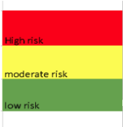

1. For each risk, recommend a response by completing the following table:

| **Event** | **Response** | **Contingency** |
| --- | --- | --- |
| Record Keeping | Record new records and fix issue | Back ups |
| System Failures | Reschedule if needed and repair system | Configure system correctly with proper back ups |
| Power outage | Checking the breakers | Having a backup generator |
| Failure of AC/Heat | Call a technician/landlord | Have a fan/space heater |
| Funding | Request more funding | Have emergency fund at all times |
| Understaffed | Try to spread out available workers or volunteers to essential areas | Proper hiring process  Proper communication with the work team |
| Security | Call the police | Have security cameras |
| Implementation | Restructuring | Prioritize essential tasks |
| Scope | Minimize/Simplify Expectations | Set realistic expectations |
| Limited Supply | Attempt to acquire more vaccines | Having a surplus storage on vaccines in the event of limited supply |
| Weather conditions | Depends on the weather condition | Having a backup venue  Keeping an eye on the weather forecasts |
| Crime | Call the police | Have security cameras |
| Natural disasters | Alert all the employees to not come to work | Keep an eye on the weather forecasts |
| Lack of advertising | Reschedule | Allocate appropriate budget to advertising |
| Lack of seating | Put a sign at the door to let people know before it gets crowded | Have extra chairs |
| Long wait times | Bring in new temporary staff | Have enough staff at all times |
| Not enough venue space | Attempt to find a new venue | Having a back up venue |
| Poor communication | Establish communication standards | having a proper chain of command |